Student Name: Azamat Salamatov

Professor Cleveland

COMP 3324 - 1

Week 4 – Lab 2 – Hash Collisions

February 28, 2023,

Hash Collisions

Contents

Hello.exe and Erase.exe files 1

My summary on this project 2a: 2

Calculating the Hash Values 3

VERY IMPORTANT My summary on Project 2b: 5

# Hello.exe and Erase.exe files

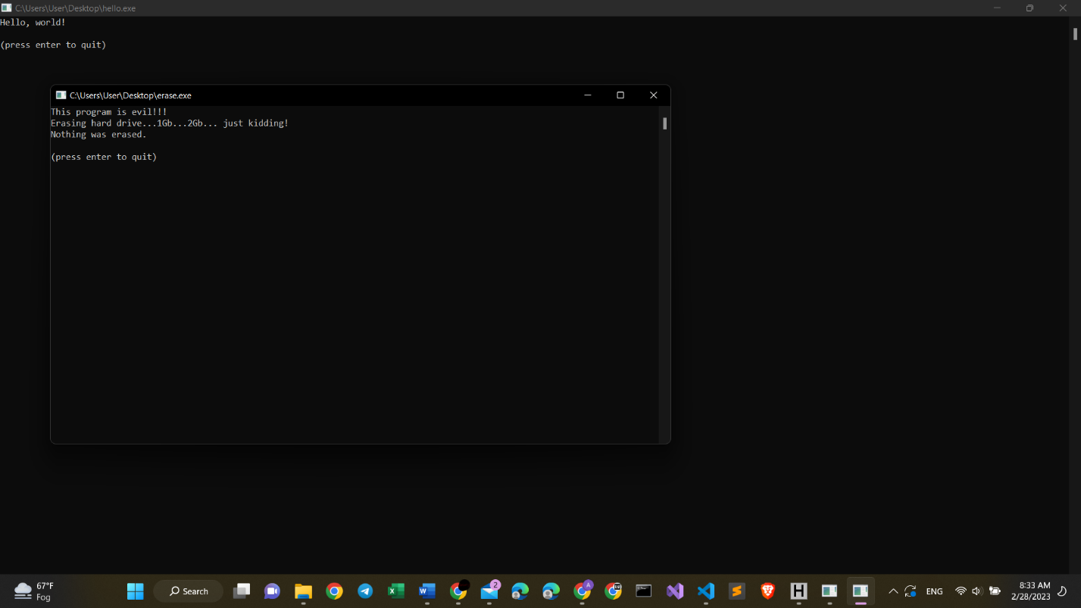

*Azamat Salamatov unit2a*

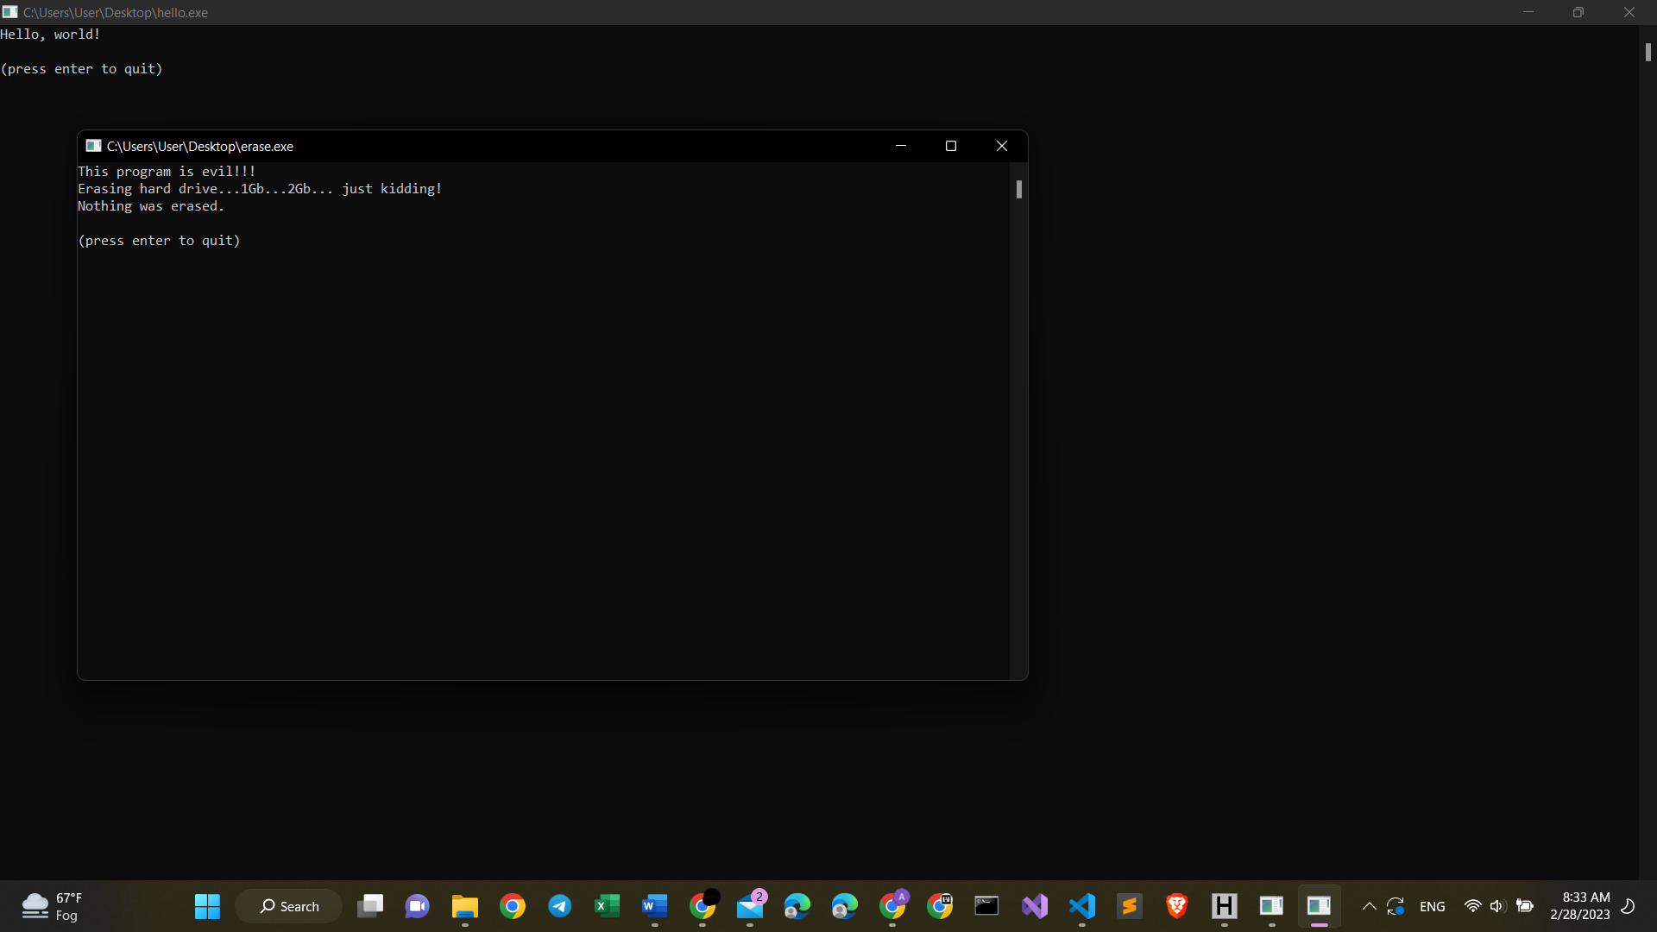

*Azamat Salamatov unit2a (zoomed in)*

# My summary on this project 2a:

* This project was not very hard, but it also needed to be aware of knowing how to extract zip files. This application hello.exe and erase.exe were downloaded from a very strange site. Its look and feel were not very pretty. Sometimes, it might be dangerous to download files from unknown sites.
* However, this part of the project is really simple.

# Calculating the Hash Values

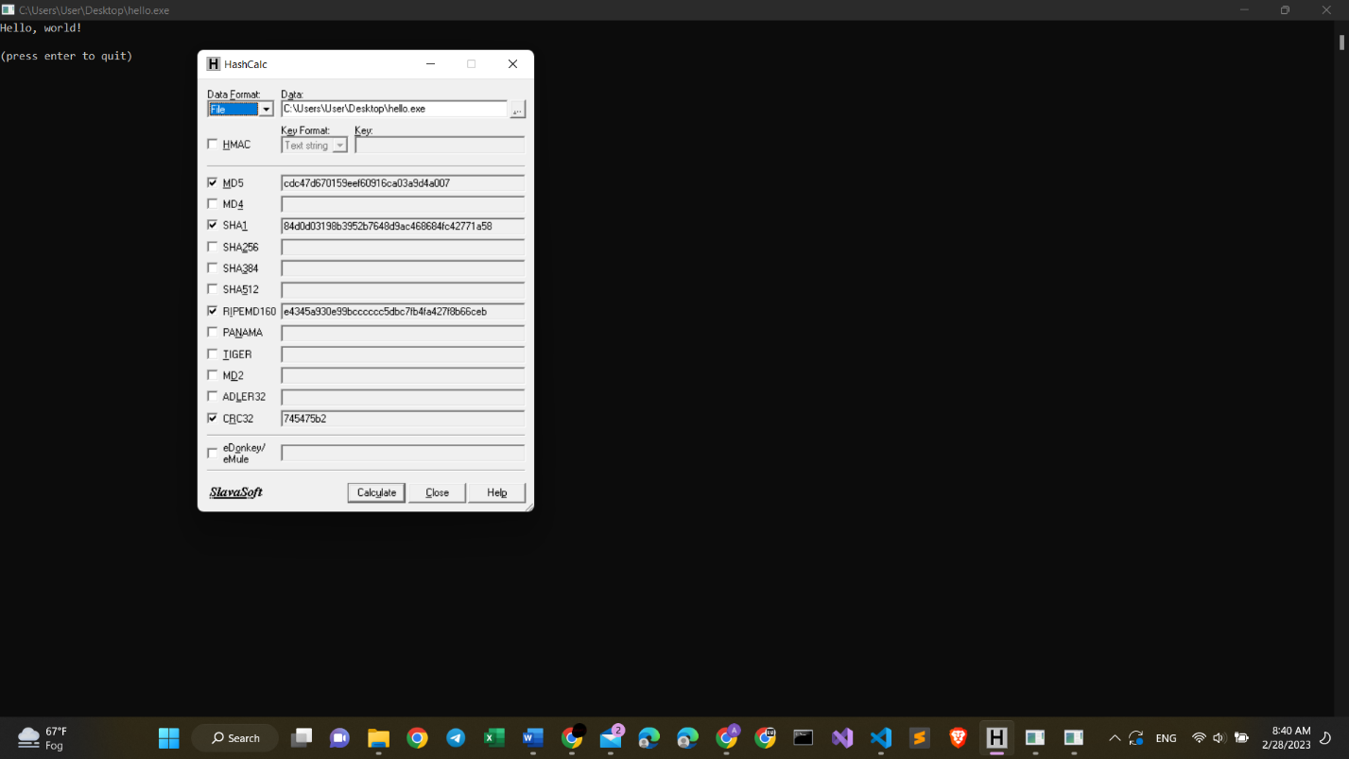

*Azamat Salamatov unit2b – hello.exe*

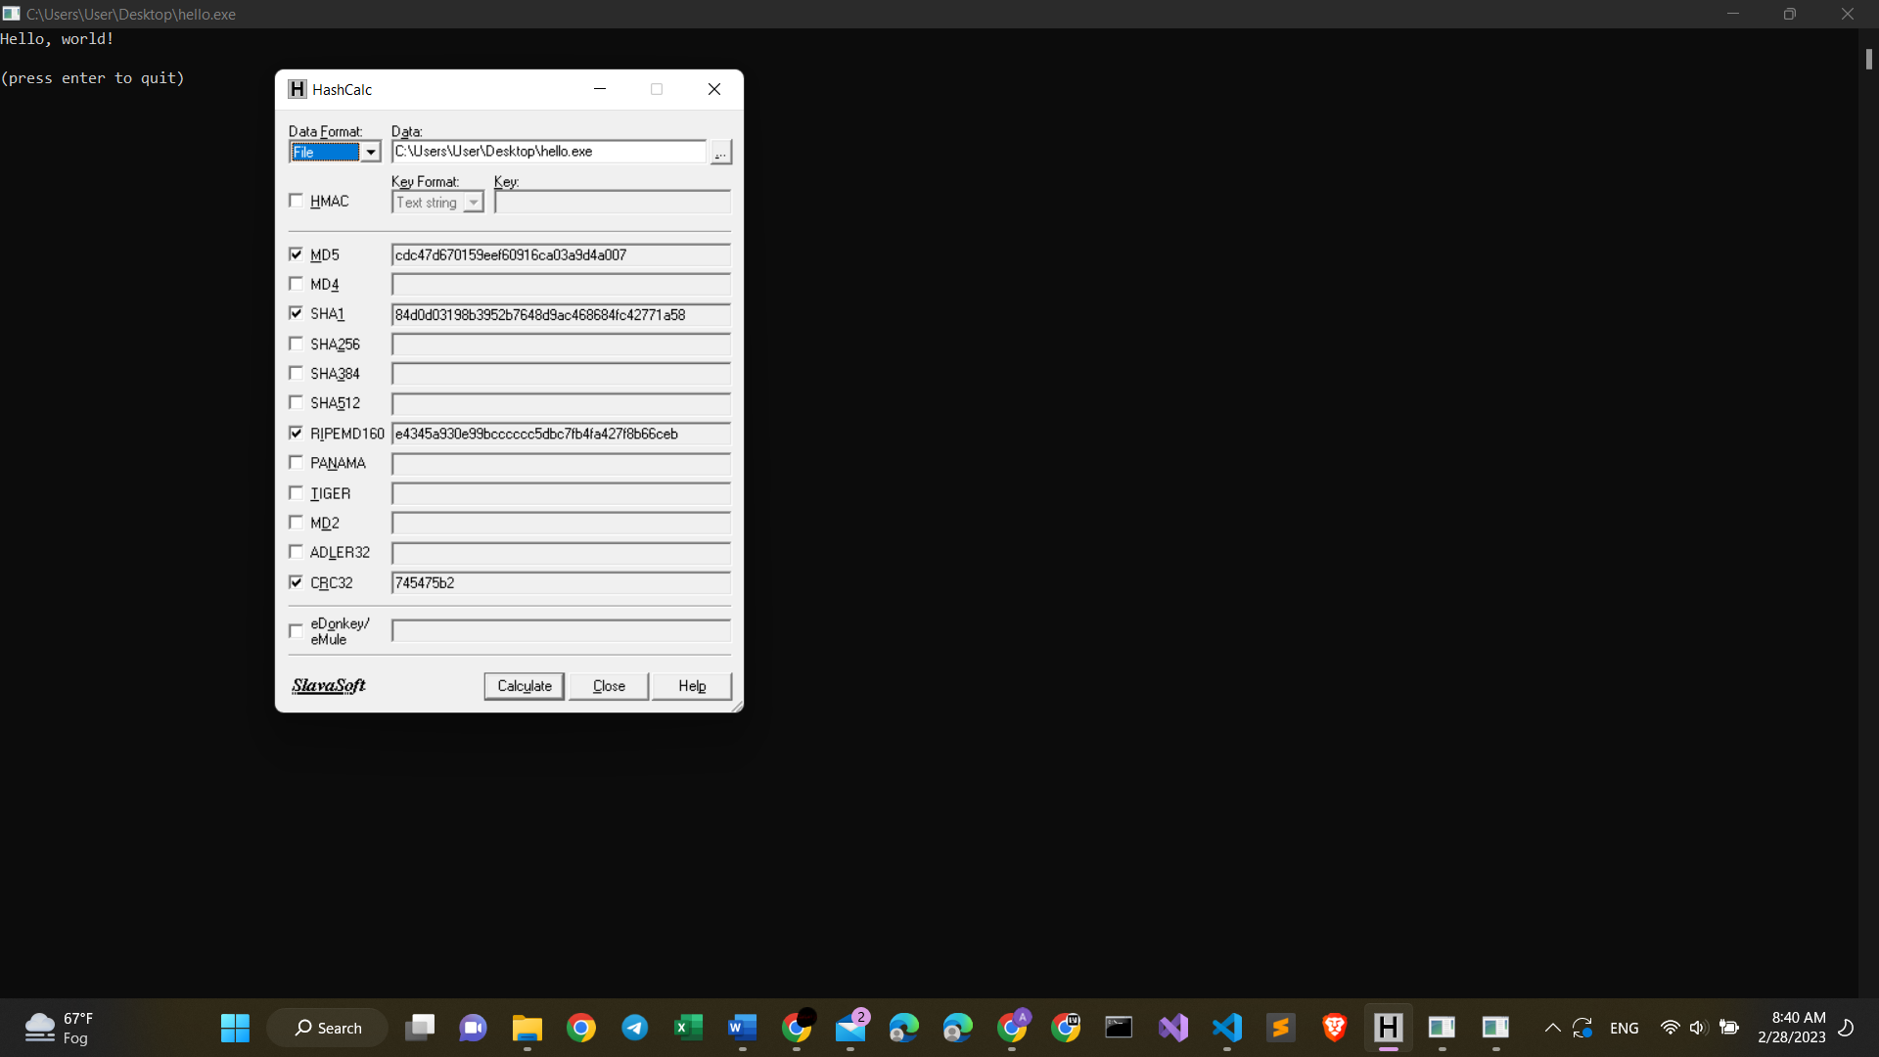

*Azamat Salamatov unit2b (zoomed in) – hello.exe*

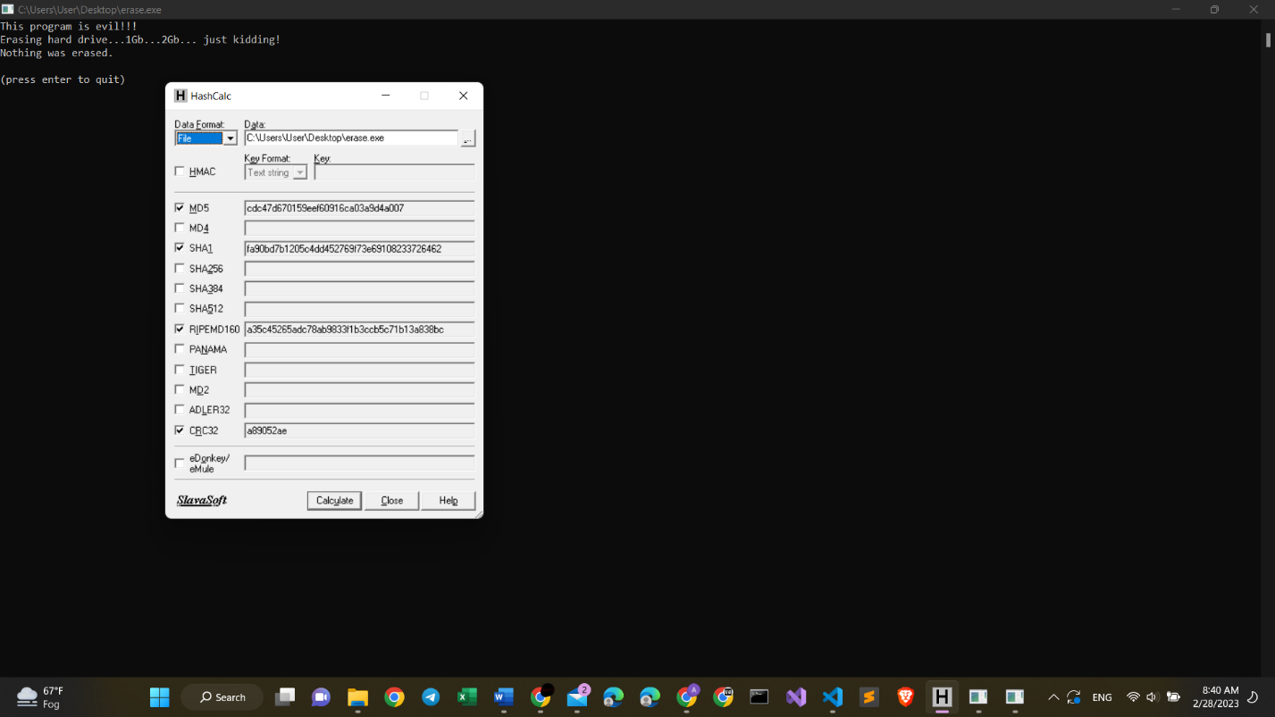

*Azamat Salamatov unit2b – erase.exe*

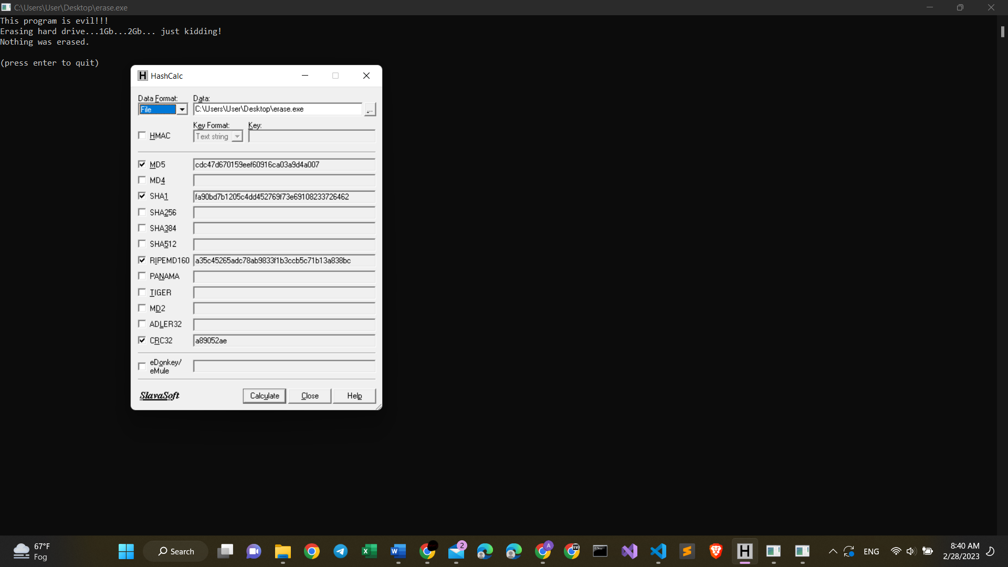

*Azamat Salamatov unit2a (zoomed in) – erase.exe*

# VERY IMPORTANT My summary on Project 2b:

* This project showed how to get MD5 data of an application.
* In computer Science, a hash collision is when two pieces of data in a hash table share the same hash value. The hash value in this case is derived from a hash function which takes a data input and returns a fixed length of bits.(Wikipedia). For example, these 2 files: hello.exe and erase exe have the same hash value(MD5):
* cdc47d670159eef60916ca03a9d4a007 – (erase.exe)
* cdc47d670159eef60916ca03a9d4a007 – (hello.exe)
* So, the summary is quite simple, hash collision happens when two pieces of data have the same hash value of MD5.